EXPERIMENT-7

AIM:
To perform basic video processing by reading a captured video in Python and displaying it in normal, slow motion, and fast motion using OpenCV.
PROGRAM:
import cv2
from tkinter import Tk, filedialog
# Hide Tkinter window
Tk().withdraw()
# Select video
video_path = filedialog.askopenfilename(
title="Select a Video",
filetypes=[("Video Files", "*.mp4 *.avi *.mov *.mkv")]
)
# Check if a video is selected
if not video_path:
print("No video selected!")
exit()
# -------- Normal Speed --------
cap = cv2.VideoCapture(video_path)
while cap.isOpened():
ret, frame = cap.read()
if not ret:
break
cv2.imshow("Normal Speed", frame)
if cv2.waitKey(30) & 0xFF == ord('q'):
break
cap.release()
cv2.destroyAllWindows()
# -------- Slow Motion --------
cap = cv2.VideoCapture(video_path)
while cap.isOpened():
ret, frame = cap.read()
if not ret:
break
cv2.imshow("Slow Motion", frame)
if cv2.waitKey(100) & 0xFF == ord('q'):
break
cap.release()
cv2.destroyAllWindows()
# -------- Fast Motion --------
cap = cv2.VideoCapture(video_path)
while cap.isOpened():
ret, frame = cap.read()
if not ret:
break
cv2.imshow("Fast Motion", frame)
if cv2.waitKey(5) & 0xFF == ord('q'):
break
cap.release()
cv2.destroyAllWindows()

INPUT:
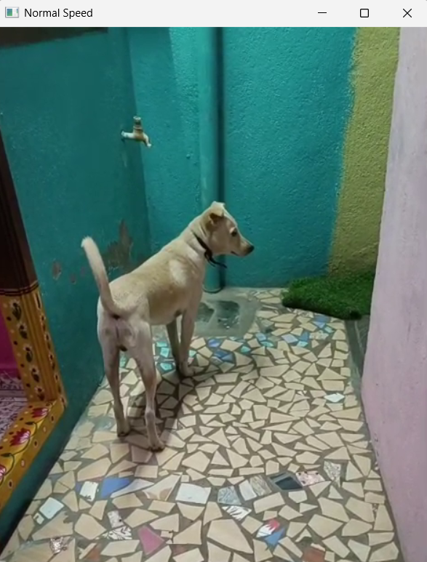
OUTPUT:
